IAM

IAM is the one of the core component of the Google cloud platform

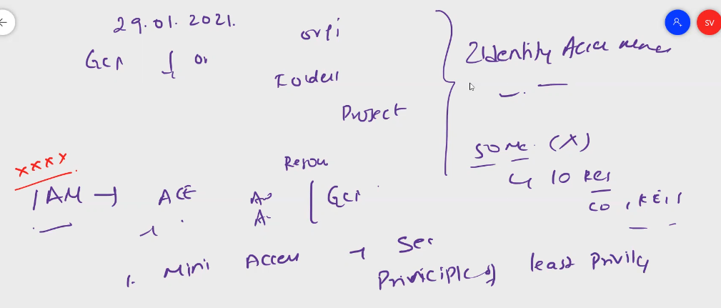

Using IAM we can implement Principles of least privileges

We can assign permissions, roles to set the security levels on resoureses

Google defined the below definition for IAM

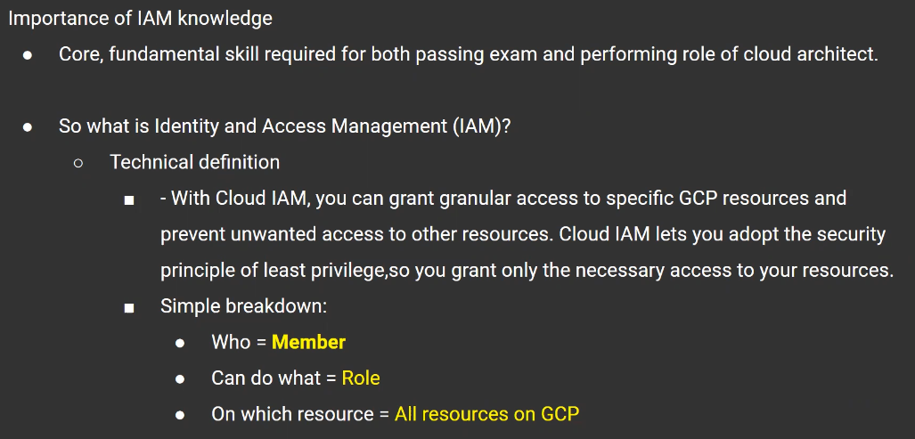

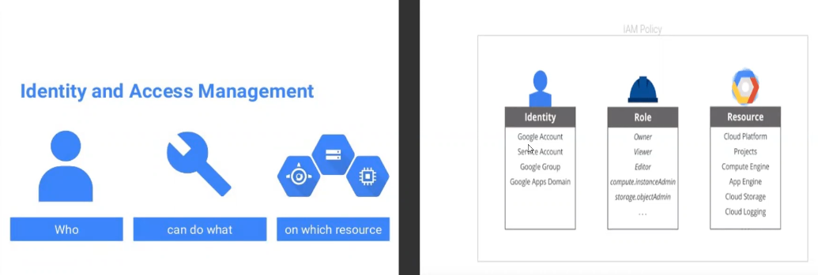

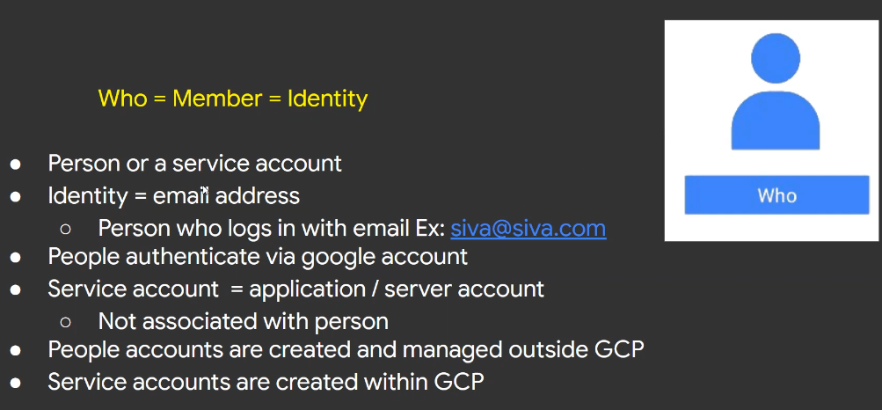

Who means member identification to set the security permissions to access the google resources

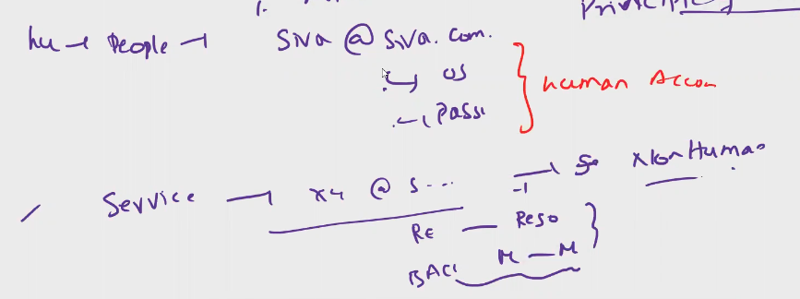

Service accounts are configured for specific service which is running continuously without interruption

Once created service accounts can not be deleted or removed – non humon accouts

*int – when new emp comes how to assign access –

Organization emails never create in google cloud – should create in google cloud admin console

In other clouds ex aws and azure, user creation can be done with in cloud console, but in gcp user creation can be done outside the google cloud

Service accounts only can be created with in the cloud

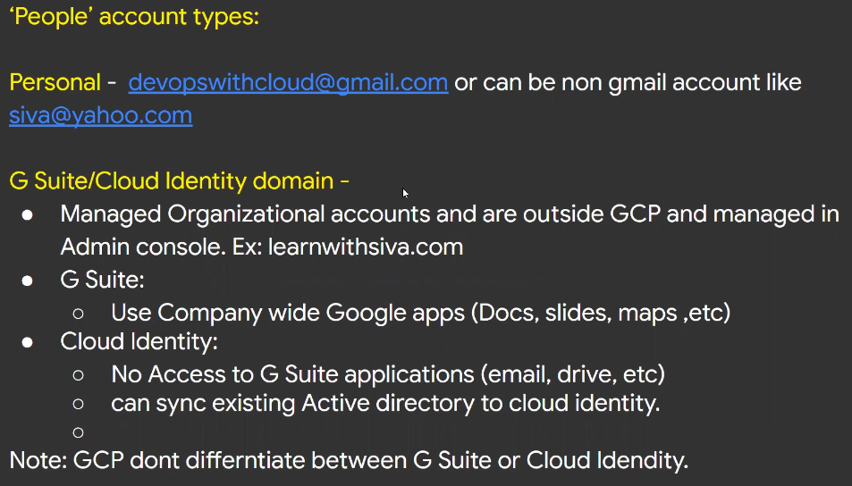

Int- what is gsuite and cloud identity accounts in gcp

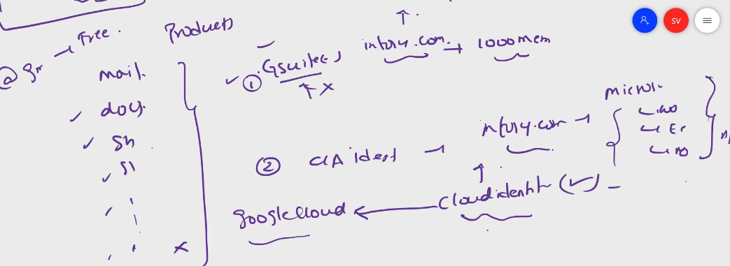

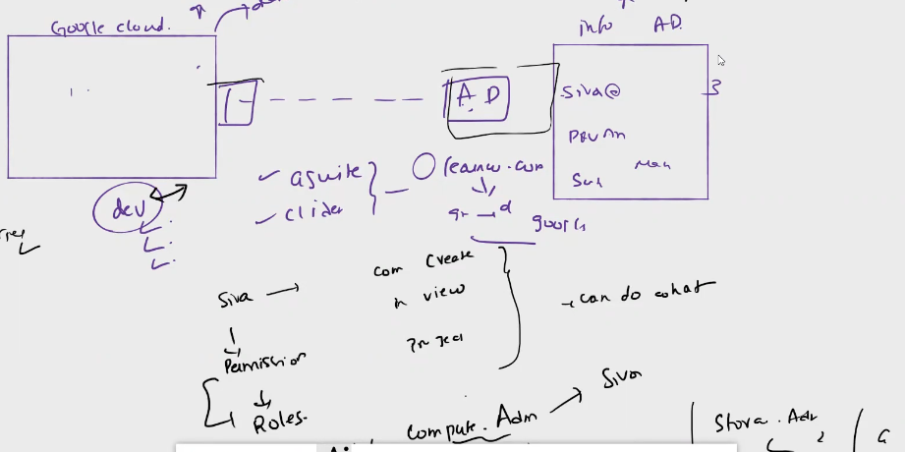

When we want to integrate user accounts from other cloud environments, we need to sync with that domain in gcp to access the google cloud resources (ex. From azure AD to gcp admin console integration), for AD integration need to use ADSync

We can use gsuite accounts or cloud identity accounts to access the resources

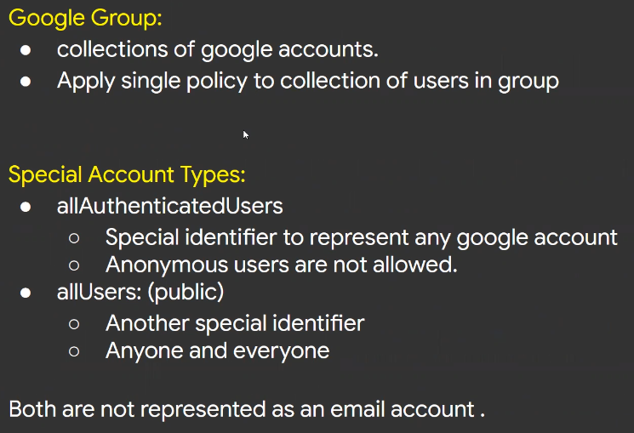

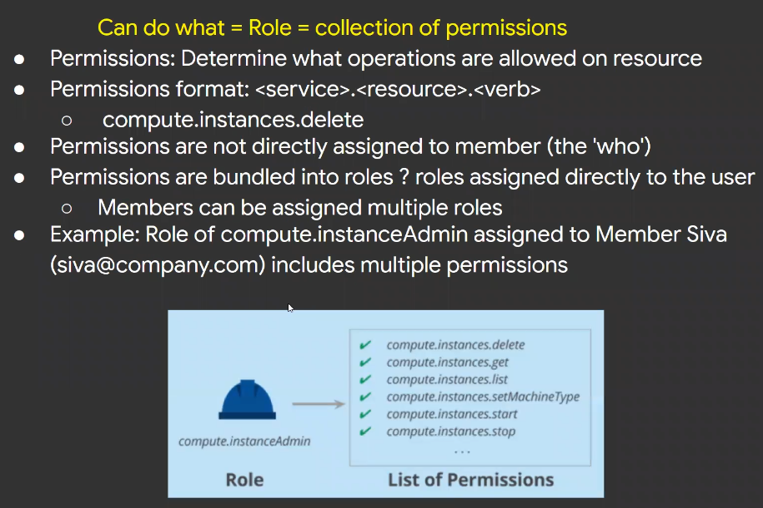

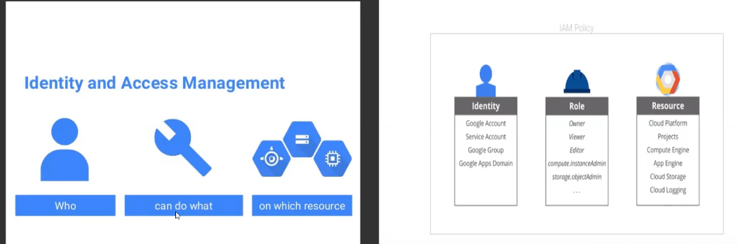

Int - Types of roles, which type of rolls you are using

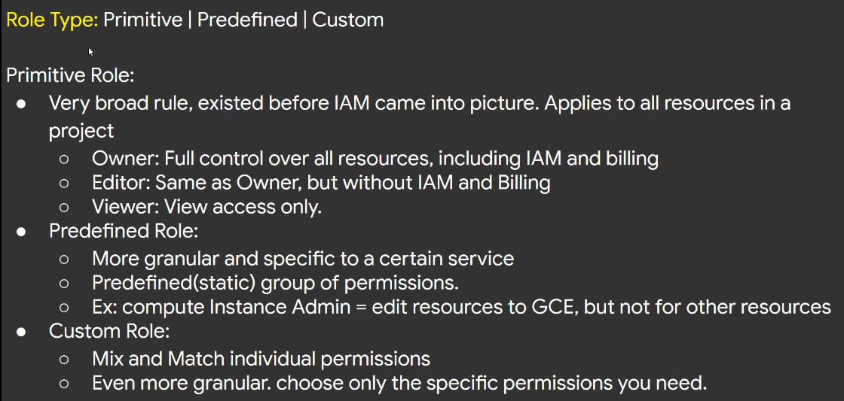

Rolls are a group of permissions

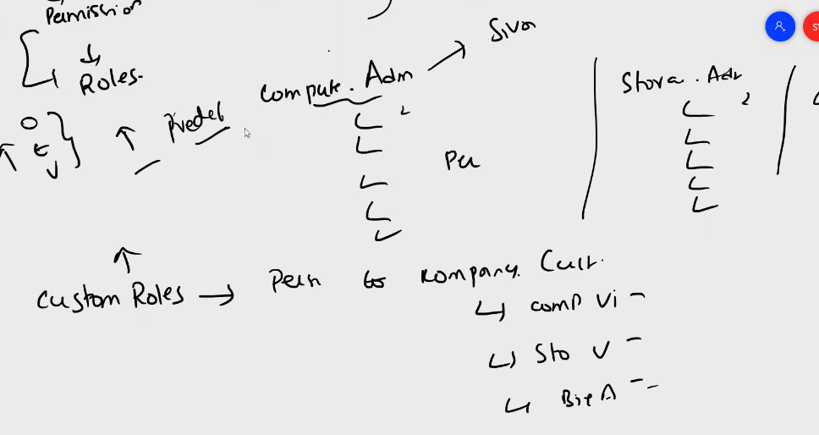

We can assign permission on organization wide and project wide

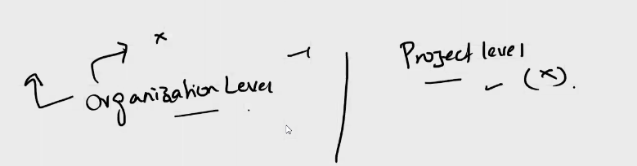

Costume roles to assign permissions on resources level, we can customize the rolls as per the requirement and assign to users

We can assign google wide roles can use primitive rolls

**User account creation**

Create an account named as Pratap

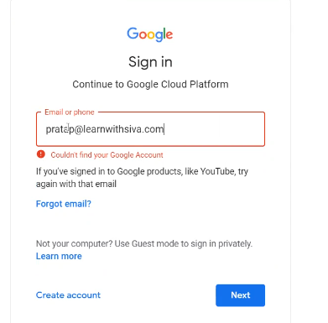

When we give first time any non existing account, we can see above login error

We have to create user accounts in admin account, for access to user we have to use console

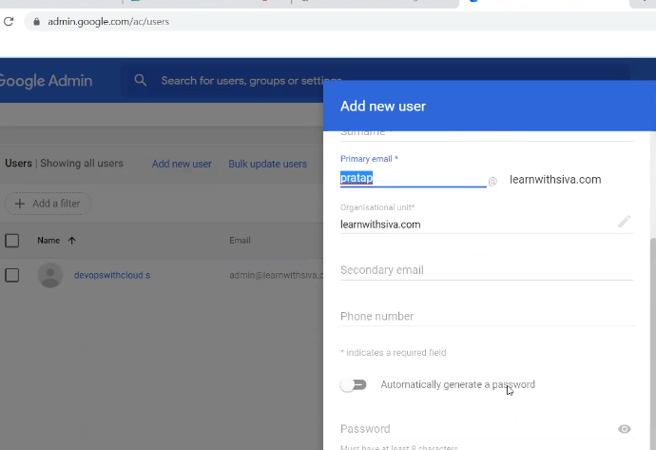

Go to google admin console, click on add new user option and provide required details to create user google cloud account

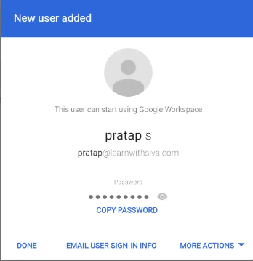

We can user gsuite accounts or google accounts or Microsoft AD to integrate ADsync to create accounts

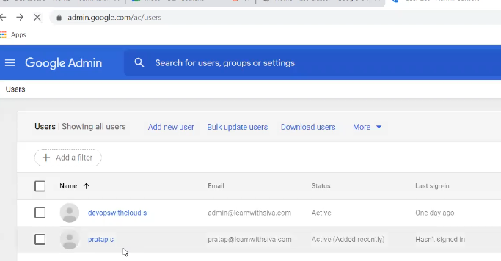

Login to user account

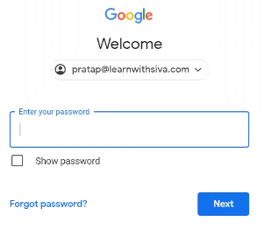

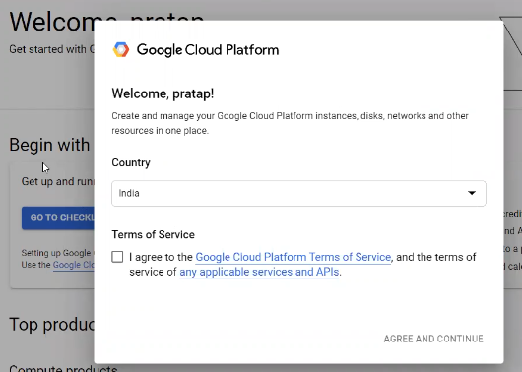

By default new users will not have access to organization or projects, can access once users are added to respective roles on admin cloud console

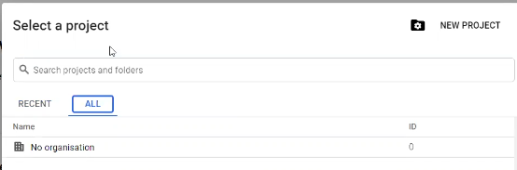

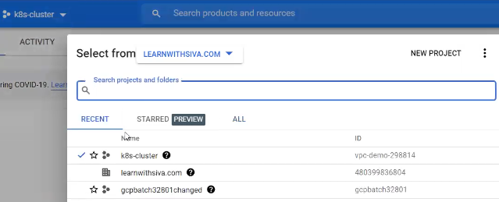

To assign permissions to users we need to go organization level, IAM and Admin option

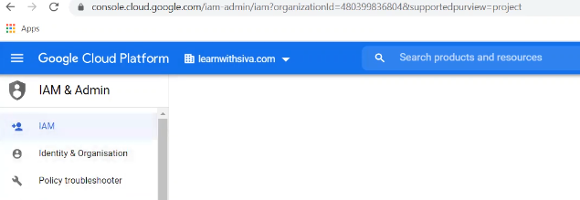

We can create and assign service accounts, assign roles, and security policies

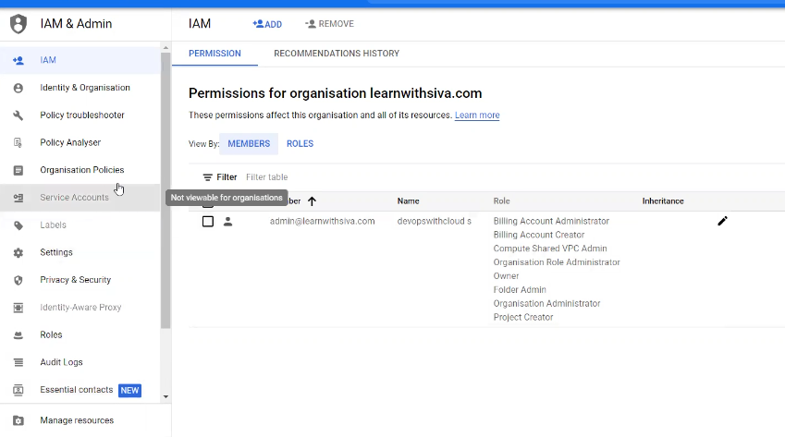

Service accounts can not be created and assigned to organization level, it should be grayed out

In IAM and Admin option need to go ADD to add users and to assign required permissions

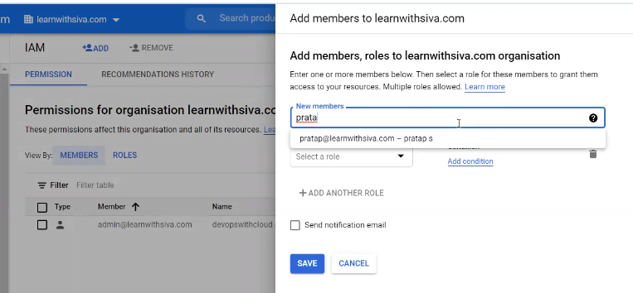

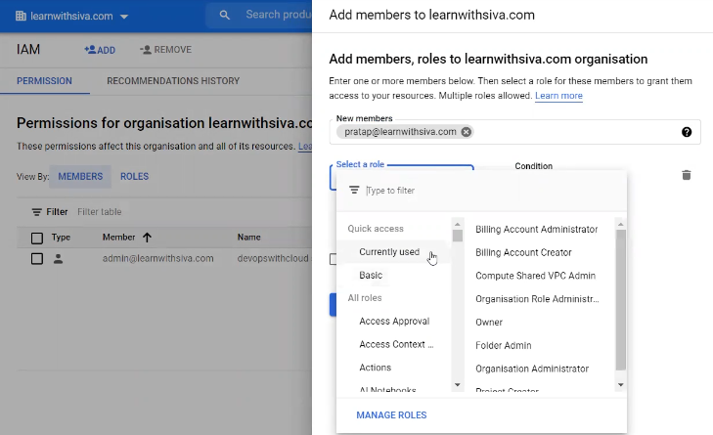

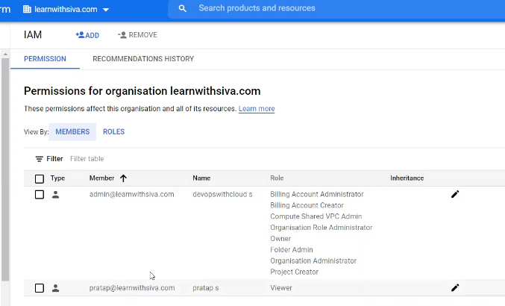

Projects are syncing to user accounts as per the permissions provided in admin console

Permissions are applied as per the provided access

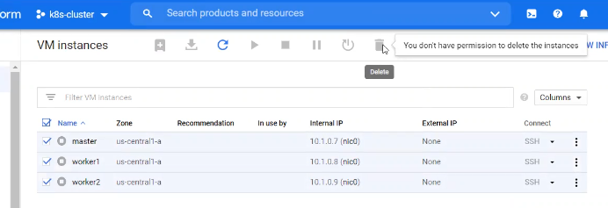

Assigning roles to see organization is depends on roles assigned to user, its not mandate to list the organization domain in users google console, be default users can not see organization domain

If we want to assign permission to list the organization, need to enable access in admin google console

Go to admin google login console, edit the previously provided access to that user and edit

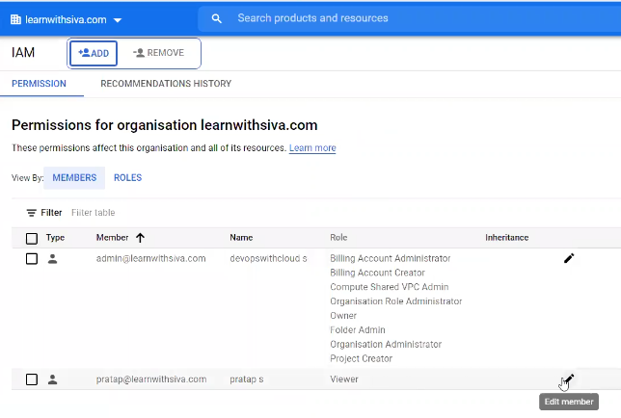

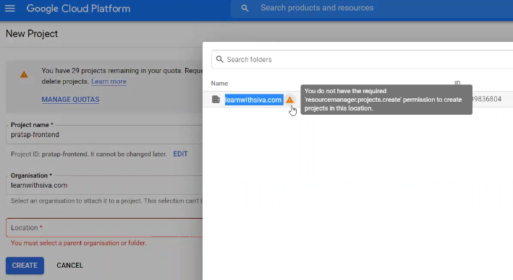

If we want to provide permission in organization level, go to users permissions, resource manager, then select viewer or administrator to manage the resources

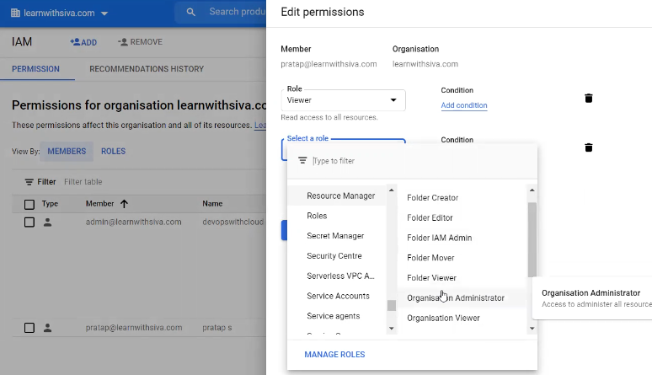

Int – if we are not seeing organization for user account, where can we grant permission, above is the answer

Now Pratap user also can view organization level

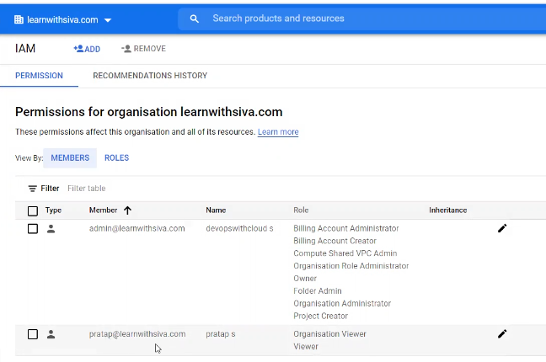

Now we can view organization in console

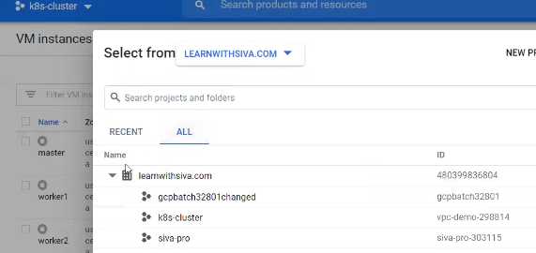

To create projects we need to associate billing account to create resources

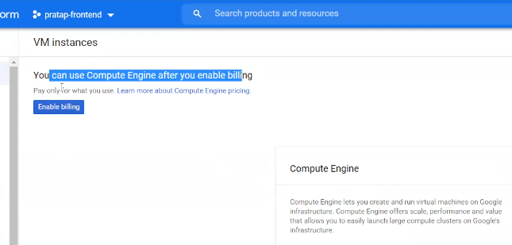

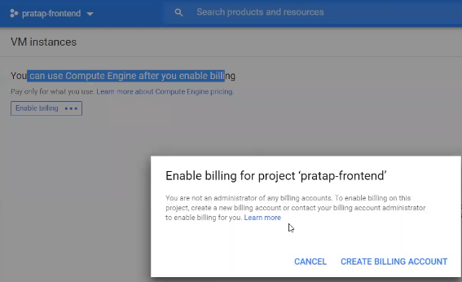

Imp – users never create billing accounts to associate projects to billing accounts, we use only cleated billing accounts in organization billing account

To enable billing we need to assign the below role to user

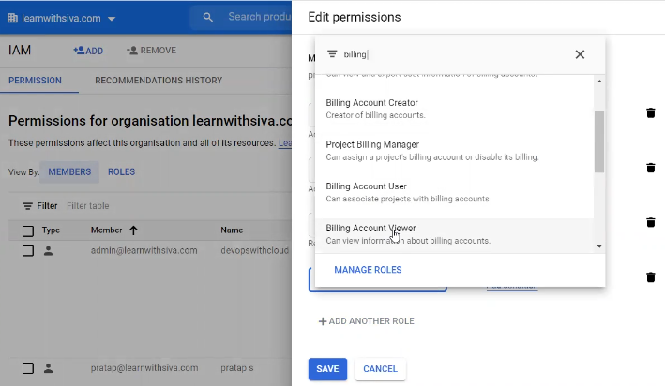

Once billing account is enabled for the project, we can create required resources by enabling API

To remove viewer role and check the permissions

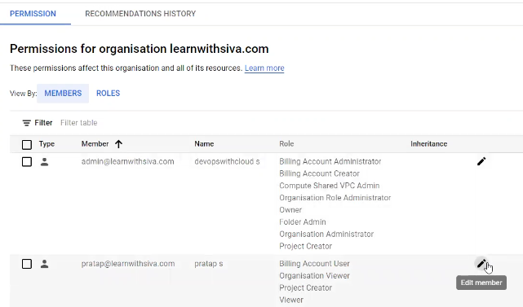

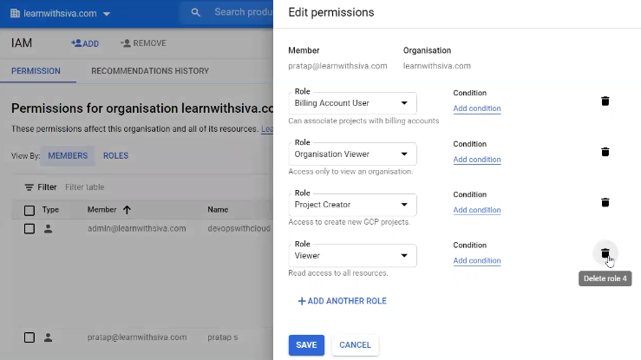

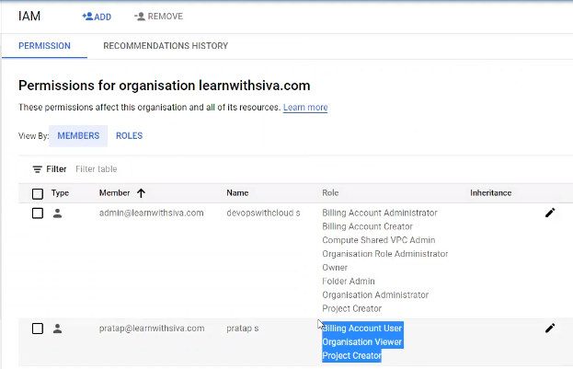

Once removed viewer role to the user, user can not view the projects except user created

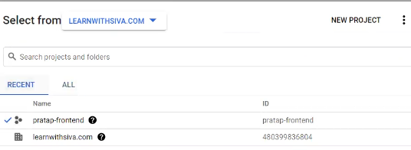

If we want to provide access to particular project, we have to go project level and go to IAM role and add the user to set the required permission

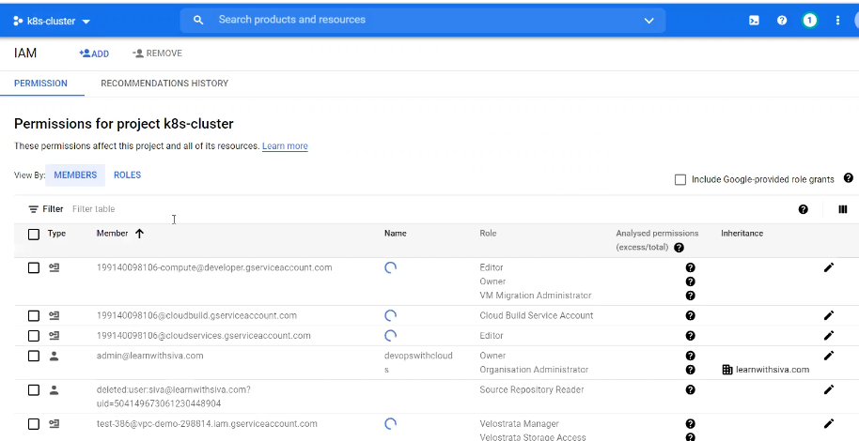

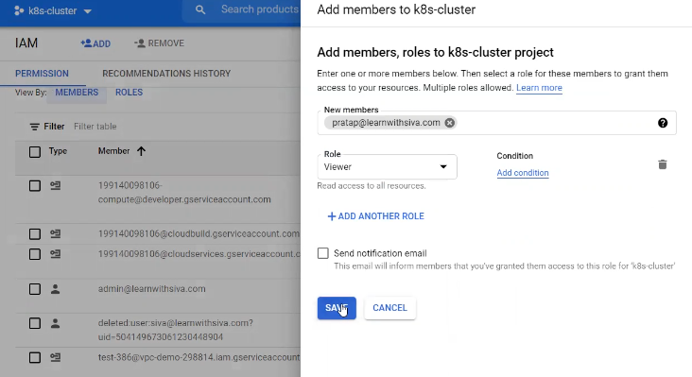

Assign viewer to project to user to view the project in users console

Now pratap can view the respective project to view

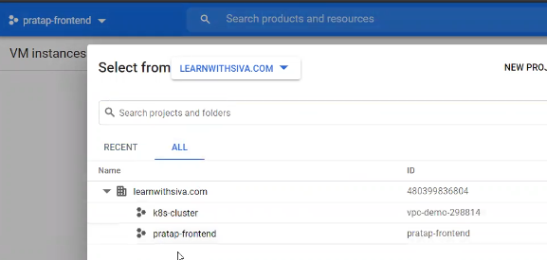

We can create groups in admin google cloud console only

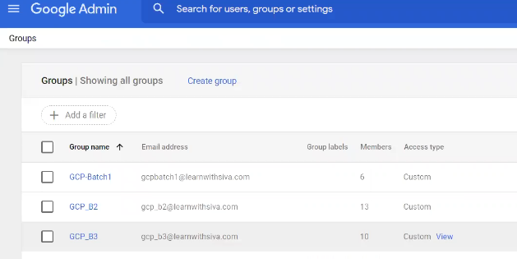

<https://cloud.google.com/iam/docs/overview>